ExpenseMate - Final Report
Complete SDLC Delivery (Phases 1–6)
Group Members:
Umair Ehtesham (24k-3041)
Rumaesa (24k-3099)
Architecture: Angular 17 SPA + ASP.NET Core 8 Web API + Microsoft SQL Server

Executive Summary & Core Requirements
ExpenseMate is a client-server financial management application that lets users log expenses, monitor budget thresholds, analyze spending, export audit logs, and view real-time remaining monthly budgets. The system was delivered across all five SDLC phases — Requirements, Design, Construction, Testing, and Maintenance & Evolution.
- FR-01 Expense Log & CRUD — full record management for amounts, dates, descriptions, categories.
- FR-02 Budget Threshold Alerts — automated triggers at 80% and 100% of monthly limits.
- FR-03 CSV Import/Export — RFC 4180-compliant file parsing and stream generation.
- FR-04 Adaptive Remaining Budget & Period Filter — dynamic Month/Year selector with live totals.
- NFR-01 Maintainability — Maintainability Index target > 85.0 / 100 (achieved: 91.2).

System Architecture
[ Presentation ] Angular 17 SPA (Reactive Forms, RxJS)
| HTTP REST / JSON (ISO 8601 UTC)
v
[ Application ] ASP.NET Core 8 Web API
ExpenseService | BudgetAlertService | CsvExportService
| Entity Framework Core 8 ORM
v
[ Data Layer ] Microsoft SQL Server
Construction of Primary Modules
- Budget Alerts Engine: BudgetAlertService.cs continuously calculates monthly expenditures against budget limits.
- CSV Import/Export Engine: CsvExportService.cs handles stream parsing, delimiter handling, and quote encapsulation.
- Category Analytics Engine: Server-side SQL grouping queries executed via EF Core LINQ projections
Testing Execution Summary

Testing Phase | Execution Focus | Cases | Pass Rate | Status
Unit Testing | Math precision, DTO validation, isolated service logic. | 42 | 100% | Passed
Integration Testing | Web API endpoints, EF Core queries, DB persistence. | 28 | 100% | Passed
System Testing | End-to-end: Expense Entry → Budget Alert → CSV Export. | 18 | 88.8% | 2 Bugs Found
Acceptance (UAT) | UI responsiveness, dynamic month selection, filtering. | 10 | 90.0% | Resolved in Ph. 5

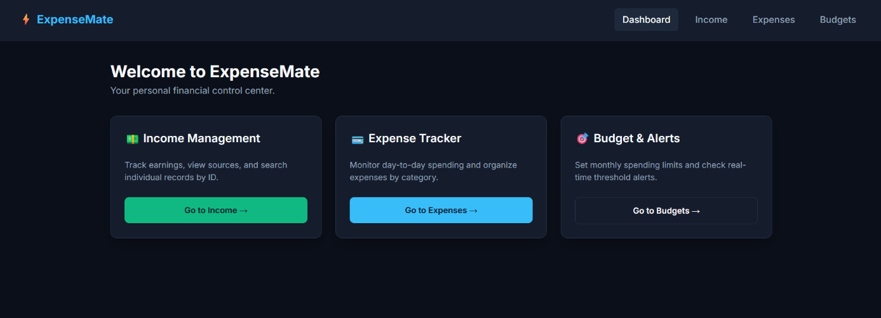
Application Screenshots

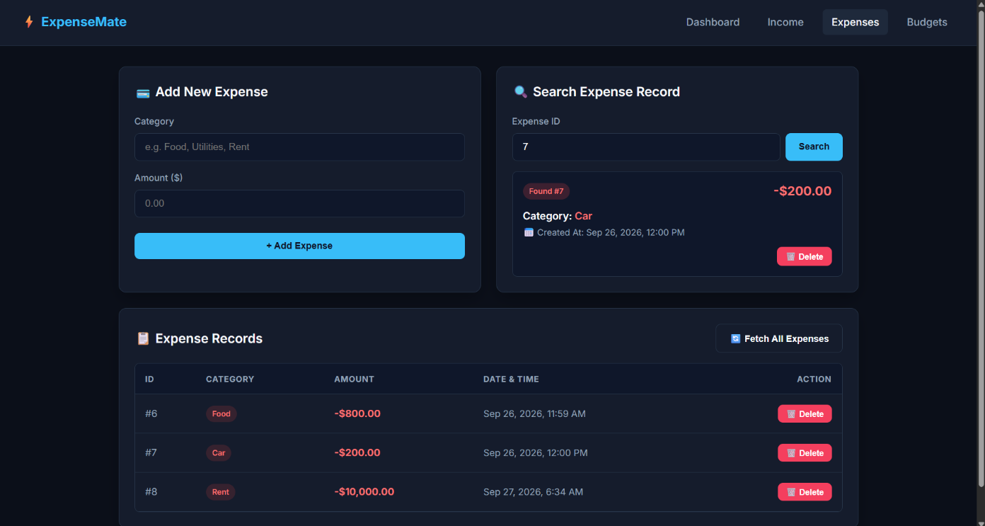
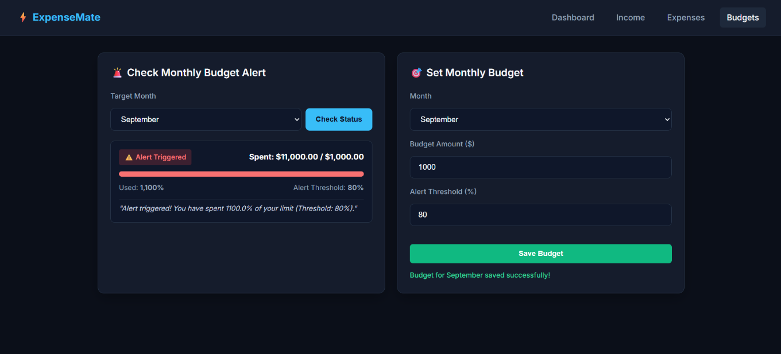
Maintenance & Evolution Highlights
Change ID | Type | Description & Outcome
CHG-ADAP-01 | Adaptive | Added Dynamic Month Dropdown with real-time Remaining Budget Calculation Engine — live balance, spend, and category breakdown per period.
CHG-CORR-01 | Corrective | Fixed Date/Time UTC serialization bug causing HTTP 400s; standardized to ISO 8601 UTC date strings.
CHG-CORR-02 | Corrective | Repaired broken "Fetch All" query logic from unhandled null checks in LINQ predicates; restores 100% accurate retrieval.
CHG-PERF-01 | Perfective | Refactored C# services to Primary Constructors and LINQ projections — 28.2% less boilerplate, MI raised to 91.2.

Final Project Sign-off Checklist
- ☑ Architecture: Local Client-Server (ASP.NET Core 8 + SQL Server + Angular 17) operational.
- ☑ Adaptive Maintenance: Dynamic Month Dropdown with Remaining Budget Balance deployed.
- ☑ Corrective Maintenance: Date/Time serialization bug & "Fetch All" query bug fully resolved.
- ☑ Perfective Maintenance: C# 12 Primary Constructors applied; Maintainability Index = 91.2.
- ☑ Evolutionary Analysis: Verified against Lehman's Laws of Software Evolution.
Final Status: ExpenseMate is 100% complete and fully verified for formal delivery.

